VTHC OHS Training Unit
OFFICE SAFETY CHECKLIST

Office
Location Date

Persons doing assessment:
Work area management representative HSR or deputy HSR
Others (employees, consultants)
This Checklist is designed to help employers identify existing or potential health and safety issues and meet their legal responsibilities in relation to health and safety in offices.

How to use this worksheet
Follow the worksheet step by step and refer to the guidance provided after each issue on the worksheet to:
- Assess any occupational health and safety (OHS) issues associated with your office; and
- Implement solutions to OHS issues and control any risk to the health and safety of employees

Consult with the relevant Health and Safety Representative (HSR) and where possible involve the employees who do the tasks when assessing the tasks and planning and introducing risk controls
Arrange for regular workplace inspections and pay particular attention to –
Office layout
Workstations
Job design
Workload and tasks
Lighting
Manual handling
Noise
Indoor air quality
Radiation
Storage, housekeeping, cleanliness and cleaning methods
Floors and stairs
Computers, copying and other equipment
Hazardous substances
Personal protective equipment
Keep a copy for your records
You should retain your risk assessment if it shows a risk to employees
Fix the problems and control any risks
This worksheet provides general guidelines only. It is important to control any risk you find, so far as is reasonably practicable

JOB DESIGN
REFER PAGE 12 OF OFFICEWISE
Examples of issues which may affect health and safety, productivity and job satisfaction:
- High repetitive physical tasks (such as keying) performed for periods of 2 hours or more at a time without significant break
- Tasks requiring sitting or standing for periods of 2 hours or more at a time
- Tasks requiring high level of concentration for periods of 2 hours or more at a time
- Excessive workload leading to long hours or taking work home
- Employees having no or limited choice of when, how and how frequently they perform some tasks or this is determined by the equipment or machine they use or by their supervisor
- Employees not trained to or able to vary tasks and postures throughout the day

ISSUE  TICK YES IF THIS ISSUE IF PRESENT | YES | RECOMMENDED SOLUTION | PERSON RESPONSIBLE TO IMPLEMENT SOLUTION | DATE FOR COMPLETION
Highly repetitive tasks (such as keying) performed for periods of 2 hours or more at a time
Tasks requiring constant sitting or standing for periods of 2 hours or more at a time
Tasks requiring high level of concentration performed or periods of 2 hours or more at a time
Individuals unable to participate in decisions about their work and choose when, how and how often they perform most of their tasks
Employees not trained or allowed to vary tasks and postures throughout the day
Individuals not given feedback regarding their work performances
Long hours of work, taking work home
Comments (i.e. when and where it is happening)

POSSIBLE SOLUTIONS

- Intersperse highly repetitive tasks with other tasks requiring different movements and postures
- Intersperse tasks requiring static or fixed postures with other tasks requiring more dynamic postures
- Intersperse tasks requiring high levels of concentration with other less demanding tasks
- Training provided on how to vary tasks and postures throughout the day
- Supervisors ensure that employees vary their tasks and postures throughout the day

SOCIAL AND PSYCHOSOCIAL ISSUES
REFER PAGE 13 OF OFFICEWISE
Examples of issues which may affect health and safety, productivity and job satisfaction:
- Employees not given training to perform their work
- Lack of consultation on changes in the content, hours, location of the job
- Client-focused or emotionally demanding work without opportunity to discuss
- Bullying behaviours in the workplace
- Potential violence from customers or intruders
- Prolong periods of night shifts or unsocial patterns
- Inconsistent management processes or discrimination

ISSUE  TICK YES IF THIS ISSUE IF PRESENT | YES | RECOMMENDED SOLUTION | PERSON RESPONSIBLE TO IMPLEMENT SOLUTION | DATE FOR COMPLETION
No or inadequate training for new employees
Employees not consulted on changes to their work content, hours and location
No support or feedback system of employees dealing with difficult or demanding customers
Bullying (harassment, intimidation, exclusion, withholding information) occurs with some employees
Employees are placed in potentially risks situations without adequate supports (handling cash, working alone or at night, working with potentially violent clients)
Discrimination against particular individuals or groups or employees
Comments (i.e. when and where it is happening)

POSSIBLE SOLUTIONS

- Documented training for all new employees
- Consultation processes for employees, e.g. regular staff meetings and processes
- Policy and procedures on prevention and management of bullying, harassment and occupational violence
- Policy, procedures and communication devices for prevention and management of potentially violent situations

MANUAL HANDLING
REFER PAGE 12 OF OFFICEWISE
Examples of issues which may affect health and safety, productivity and job satisfaction:
- Lifting or carrying large, heavy or awkward office equipment, files or items
- Repeatedly lifting, carrying, pushing or pulling items for more than 30 minutes at a time or more than two hours in the day
- Storing often handled items below mid-thigh height or above shoulder height leading to risks from bending, twisting and reaching
- Pushing heavy trolleys on high resistance surfaces or steep ramps
- Tasks such as keying or hand stapling performed repetitively for more than 30 minutes at a time or more than two hours in the day

ISSUE  TICK YES IF THIS ISSUE IF PRESENT | YES | RECOMMENDED SOLUTION | PERSON RESPONSIBLE TO IMPLEMENT SOLUTION | DATE FOR COMPLETION
Large, awkward or heavy items handled manually
Repetitive handling tasks over 30 minutes or for two hours over the day
Handling items for a long duration
Heavy trolleys used on resistant surface or ramps
Repeatedly handling items outside preferred (mid-thigh to shoulder) working zone
Comments (i.e. when and where it is happening)

POSSIBLE SOLUTIONS

- Use powered mechanical aids to handle large, bulky or awkward items or if not reasonably practicable, use an ergonomically designed trolley
- Use lifts where possible for moving loads, or if not reasonably practicable, use ramps or use suitable trolleys on stairs. Loads should not be carried by hand on stairs. If this is not possible. Ensure the load is small and light enough to carry in one hand to the side of the body
- Relocate frequently used items to within the preferred working zone
- Use powered office equipment such as staplers, hole punchers or binders to reduce the high-force actions sometimes required to operate manual equipment
- Design rest or work breaks into the tasks to allow for muscles that have been working to rest and recover
- Set up workstations to prevent awkward postures
- Move and stretch or regular intervals

ENVIRONMENTAL FACTORS
REFER PAGE 22 OF OFFICEWISE
Examples of issues which may affect health and safety, productivity and job satisfaction:
- Poorly lit work areas and walk ways; sudden changes in lighting levels occur between areas, i.e. between outdoors and a dimly lit stairwell, or between outdoors and loading bay; lighting that is badly directed, lighting throwing distracting shadows or steps, stairs, walking surfaces, etc; lighting that can make it difficult to see for the pedestrians or mobile equipment operators
- Employees not able to control incoming natural light; artificial lighting causing reflections fro work surfaces or shadows over the task; not enough light for the tasks; employees report tired, sore or irritated eyes
- Difficult to hear a normal voice within a 1 metre distance; distracting or disruptive noises in the ara; screens or partitions do not control noise
- Staff suffer from dry, irritated eyes at the end of the day; office is stuffy; staff find the temperature cold, hot or fluctuating
- Radiation emissions from old CRT monitors not rested within the last 12 months; staff located closer than 1 metre from a CRT monitor or any direction; no policies and procedures for the placement and size of CRT monitors; staff located near multiple electrical cords or computer cables; electrical and computer cables unhoused or entwined near staff
- Working in very cold or hot conditions

ISSUE  TICK YES IF THIS ISSUE IF PRESENT | YES | RECOMMENDED SOLUTION | PERSON RESPONSIBLE TO IMPLEMENT SOLUTION | DATE FOR COMPLETION
Insufficient lighting for task or security
Employees not able to control natural light or glare
Artificial lighting causing reflections from work surfaces or shadows over the task
Uncorrected visual problems I persons required to undertake visually demanding tasks
Noise loud enough to make it difficult to hear a normal voice at 1 metre distance
Distracting or disruptive noises present that affect the employees in the area
Temperature too hot, too cold or fluctuating and affects the employees in the area
Air flow too high and affects the employees in the area
Air flow too low and affects the employees in the area
Inadequate ventilation for photocopiers and other equipment
Persons constantly working in close proximity to radiation sources, i.e. rear of CRT monitors, microwaves etc
Other environmental factors
Cont’d.
Comments (i.e. when and where it is happening)

POSSIBLE SOLUTIONS

- Use recommendations from AS1680.1 to choose appropriate lighting levels for tasks
- Install blinds, curtains or shutters on windows to control external light sources
- Improve office lighting by relocating or increasing lighting
- Improve office lighting by replacing defective light sources; cleaning light sources; increasing the wattage of the light source; replacing light source with a more suitable type or colour
- Provide graduated lighting between areas
- Provide eyesight testing for employees engaged in visually demanding tasks
- Direct lighting so that it does not throw distracting shadows on steps, stairs or other walking surfaces
- Isolate persons or control and noise of items of plant or equipment
- Increase the height, direction or sound absorbency screens or partitions to reduce noise level
- Adjust the air flow in the office or redirect the air flow
- Install extraction fans around photocopiers and other such equipment in frequent use
- Redesign layout so that persons are not required to work in close proximity to possible radiation sources for long periods of time
- Check that employees are not exposed to environmental factors that may affect behaviour or performance, e.g. heat, cold, chemicals or electricity

OFFICE LAYOUT
REFER PAGE 32 OF OFFICEWISE
Examples of issues which may affect health and safety, productivity and job satisfaction:
- Insufficient space for the equipment and the operator
- Insufficient space for light, intermediate and busy foot traffic
- Insufficient circulation space around each workstation
- No separate area for photocopying

ISSUE  TICK YES IF THIS ISSUE IF PRESENT | YES | RECOMMENDED SOLUTION | PERSON RESPONSIBLE TO IMPLEMENT SOLUTION | DATE FOR COMPLETION
Inadequate space for tasks to be carried out
Insufficient space for busy or intermediate foot traffic through an area
Insufficient space for individual workstations
No areas for tasks that require dedicated space, i.e. photocopying
Inappropriate floor surfaces for the tasks (slippery, reflective, difficulties with pushing equipment)
Comments (i.e. when and where it is happening)

POSSIBLE SOLUTIONS

- Relocate equipment and workstations to provide adequate space for the tasks being performed
- Review the tasks being conducted and consider whether they need to be done in that office for in another location
- Space for busy foot traffic must comply with the requirements of the Building Code of Australia
- Ensure aisle widths of a least 1 metre in intermediate foot traffic areas
- Allocate areas for tasks that require dedicated space and install appropriate workstations for those tasks

WORKSTATIONS
REFER PAGE 34 OF OFFICEWISE
Examples of issues which may affect health and safety, productivity and job satisfaction:
- Insufficient space at the workstation for documents to be spread out within easy reach; no easy access to equipment such as a telephone and keyboard; no height adjustability of work surfaces; workstations and equipment not set up to reduce awkward postures
- Standing workstations not suitable for all users; insufficient width and depth for the tasks being carried out; no provision for sitting at this workstation when short periods of continuous work are required
- Reception desks or counters too deep or high, inadequate work space or risk to security of staff
- Chairs unstable when sitting down or standing up; chairs not adjustable or different users; chairs damaged or uncomfortable
- No footrests provided for office workers who cannot rest their feet flat on the floor when their chair is adjusted to suit the desk height
- No suitable document holders available should user require one
- Staff not trained to adjust workstations and chair
- Frequent telephone tasks without headsets

ISSUE  TICK YES IF THIS ISSUE IF PRESENT | YES | RECOMMENDED SOLUTION | PERSON RESPONSIBLE TO IMPLEMENT SOLUTION | DATE FOR COMPLETION
Seated workstations not designed for suitability for tasks done
Reception or counter area desks not suitable for the tasks
Standing workstations unsuitable for users
General office workstation seating inadequate
Receptionist chairs inadequate
Keyboard operator chairs inadequate
Meeting / board room chairs inadequate
No headsets provided for frequent telephone work
Comments (i.e. when and where it is happening)

POSSIBLE SOLUTIONS

- Assess each workstation using workstation checklist on following page
- Provide adjustable height sitting workstations
- Design reception or counter areas to reflect the work being done and the level of security necessary
- Provide adjustable height standing workstations
- Provide suitable adjustable seating to match the type of work and the floor surfaces, i.e. glides or braked castors on hard floor surfaces

SETTING UP YOUR WORKSTATION
Chair
Is the chair adjusted to fit you? Check that the –
- Backrest height and back tilt are adjusted to fit the curve of the user’s back and allow a slightly reclined posture
- Seat height and angle are adjusted so that user can sit with their feet flat on the floor, hips between 90 degrees and 120 degrees
- An adjustable-height footrest is supplied if you need one

Have you been shown how to adjust the chair to correctly support the body?

Desk / Bench

Has the desk height been adjusted so the surface is set just below your elbow height?

If the desk is not adjustable, is the surface set just below your elbow height (e.g. chair raised slightly, footrest supplied?

Is the desk large enough to fit the task requirements of the job?

Is the desk deep enough to allow the computer screen to be approximately at arm’s length away from you?

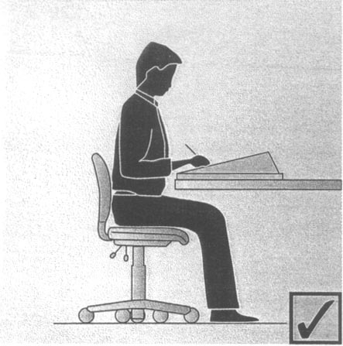

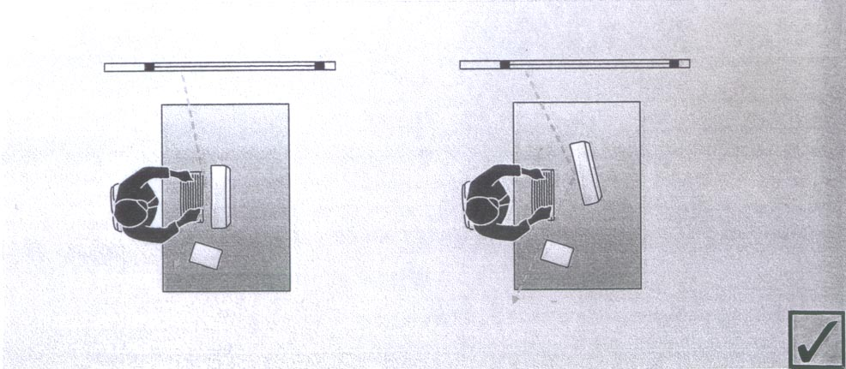

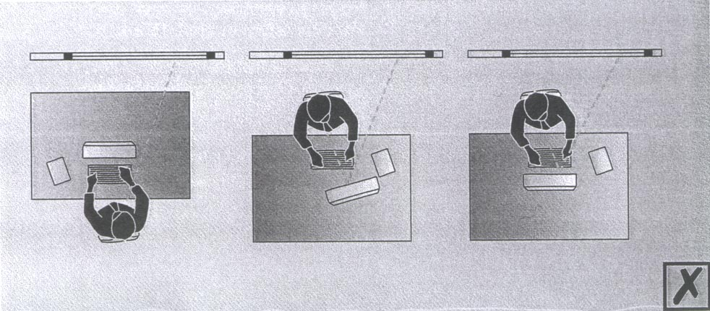

Chair
Is the chair adjusted to fit you? Check that the –
- Backrest height and back tilt are adjusted to fit the curve of the user’s back and allow a slightly reclined posture
- Seat height and angle are adjusted so that user can sit with their feet flat on the floor, hips between 90 degrees and 120 degrees
- An adjustable-height footrest is supplied if you need one

Have you been shown how to adjust the chair to correctly support the body?

Desk / Bench

Has the desk height been adjusted so the surface is set just below your elbow height?

If the desk is not adjustable, is the surface set just below your elbow height (e.g. chair raised slightly, footrest supplied?

Is the desk large enough to fit the task requirements of the job?

Is the desk deep enough to allow the computer screen to be approximately at arm’s length away from you?

STORAGE
REFER PAGE 45 OF OFFICEWISE
Examples of issues which may affect health and safety, productivity and job satisfaction:
- Insufficient storage space at each workstation
- Storage space not within easy reach (i.e. between shoulder and mid-thigh height)
- Insufficient space around storage areas to enable easy and safe access
- Filing cabinets and cupboards unstable when open

ISSUE  TICK YES IF THIS ISSUE IF PRESENT | YES | RECOMMENDED SOLUTION | PERSON RESPONSIBLE TO IMPLEMENT SOLUTION | DATE FOR COMPLETION
Workstation storage inadequate for task
Insufficient shelving storage
Heavy items stored outside preferred working zone
Inadequate general storage
Unstable filing cabinets and cupboards when open
Comments (i.e. when and where it is happening)

POSSIBLE SOLUTIONS

- Provide additional storage close to workstations
- Relocate infrequently used items to off-site storage
- Provide additional shelf storage
- Relocate heavy items to shelving between knee and shoulder height
- Provide additional general storage areas
- Secure filing cabinets and cupboards to the wall or floor to prevent them falling over
- Provide filing cabinets fitted with locking devices to prevent opening of more than one drawer at a time

OFFICE EQUIPMENT and TOOLS
REFER PAGE 40 OF OFFICEWISE
Examples of issues which may affect health and safety, productivity and job satisfaction:
- Insufficient, unsuitable, unsafe or inadequate equipment and hand tools provided
- Sharp implements (such as pen knives and stapler removers) not housed or stored so as to minimise the risk of injury

ISSUE  TICK YES IF THIS ISSUE IF PRESENT | YES | RECOMMENDED SOLUTION | PERSON RESPONSIBLE TO IMPLEMENT SOLUTION | DATE FOR COMPLETION
No electric stapler for tasks that require frequent stapling
No heavy duty stapler for stapling thick documents
High frequency staple removal using hand pincer type tool
Letter openers and other sharp tools exposed
Frequent use of hand letter openers
Use of high force to operate hole punch on thick documents
Comments (i.e. when and where it is happening)

POSSIBLE SOLUTIONS

- Provide access to electric stapler and heavy duty stapler
- Provide lever action staple remover for frequent staple removal
- Store sharp tools in a manner that does not expose persons to risk of being stabbed or cut
- Provide letter opening machines for bulk opening of letters
- Provide powered hold punch or a mechanical punch designed specifically for thick documents

COPYING EQUIPMENT
REFER PAGE 57 OF OFFICEWISE
Examples of issues which may affect health and safety, productivity and job satisfaction:
- Copier lids not functioning to reduce exposure to intense light
- Copier not functioning quietly and as quickly as indicated in the specifications for the equipment
- Self-contained toner cartridges not supplied in a sealed state
- Safety procedures for use and maintenance not available or regularly reviewed

ISSUE  TICK YES IF THIS ISSUE IF PRESENT | YES | RECOMMENDED SOLUTION | PERSON RESPONSIBLE TO IMPLEMENT SOLUTION | DATE FOR COMPLETION
Copier not functioning correctly
Printer not functioning correctly
No safe use or maintenance procedures
New toner cartridges not supplied in sealed state
Used toner cartridges not stored in sealed state
Material Safety Data Sheet (MSDS) on toners not readily available
Comments (i.e. when and where it is happening)

POSSIBLE SOLUTIONS

- Repair or replace equipment
- Prepare safe use and maintenance procedures
- Ensure supplier provides toner cartridges in sealed state
- Store used toner cartridges in sealed container
- Post copies of current toner MSDSs close to photocopiers

HAZARDOUS SUBSTANCES
REFER PAGE 58 OF OFFICEWISE
Examples of issues which may affect health and safety, productivity and job satisfaction:
- No list of the likely hazardous substances
- Hazards have not been identified, assessed and controlled
- Noticeable fumes in the air
- Work processes that us or generate dust, smoke, fumes or gases
- Chemicals in the office known to be toxic, corrosive, inflammable or explosive
- No MSDS and written safe work procedures accessible
- Inadequate ventilation to remove odours and fumes
- No training provided to relevant staff

ISSUE  TICK YES IF THIS ISSUE IF PRESENT | YES | RECOMMENDED SOLUTION | PERSON RESPONSIBLE TO IMPLEMENT SOLUTION | DATE FOR COMPLETION
Chemicals, glues, paints and other hazardous substances used without safe work procedures
Odours and fumes noticeable
Processes that generate dust, smoke, fumes or gases
Presence of chemicals or products known to be toxic, corrosive, inflammable or explosive
Chemicals or products stored or used in areas without adequate ventilation
No MSDS accessible near the chemicals
Chemicals training inadequate
Comments (i.e. when and where it is happening)

POSSIBLE SOLUTIONS

- All hazardous substances in use identified, assessed and controlled with documented safe work procedures
- Eliminate or isolate processes that generate dust, smoke, fumes or gases
- Eliminate chemicals or products known to be toxic, corrosive, inflammable or explosive or substitute with less hazardous chemicals or products
- Ensure good ventilation of areas where chemicals and products are stored or used
- Provide chemical training to all staff required to use chemicals and products

HOUSEKEEPING
REFER PAGE 59 OF OFFICEWISE
Examples of issues which may affect health and safety, productivity and job satisfaction:
- Deep carpeted areas in high use trolley areas
- Wet surfaces near external doors where traffic and weather brings in rain; in kitchen areas, particularly around sinks, urns
- Wet / polish cleaning of floors during working hours
- Change of surfaces – carpeted office to polished timber office; sheet vinyl hallway to tiled kitchen; concrete car park to terrazzo office
- High heeled shoes worn on step or straight ladders or expanded mesh flooring
- Floor surfaces not properly maintained with damaged tiles, frayed carpet
- Lifts, escalators, etc. not in good working order, e.g. differences in height of lift and floor; damage to escalator comb that may lead to a trip; damage to escalator handrail that may cause injury
- Sharp corners or edges of furniture and other fittings close to pedestrian traffic areas

ISSUE  TICK YES IF THIS ISSUE IF PRESENT | YES | RECOMMENDED SOLUTION | PERSON RESPONSIBLE TO IMPLEMENT SOLUTION | DATE FOR COMPLETION
Inappropriate floor surfaces
Areas that may have wet surfaces
Sudden changes in floor surfaces
Inadequately maintained floor surfaces
Poor housekeeping
Inadequately maintained lifts or escalator
Inappropriate footwear worn for the task
Flight of stairs without hand rails
Ramps that are too steep or with slippery surface
Hand trolleys used on ramps without edge protection
No system for removing and repairing damaged or faulty equipment
Sharp corners of furniture and other fittings
Comments (i.e. when and where it is happening)

Cont’d
POSSIBLE SOLUTIONS

- Use slip-resistant floor surface in areas where ice, grease or dust create a slipping hazard. Slip resistant door mats at entrances should be secured or large enough to remain in place
- Hazardous warning signs and procedures for the immediate management of spills
- Cleaning of floor surfaces outside working hours; or use in effective system to exclude personnel from floors that may be hazardous until dry after cleaning
- Floor surfaces must be chosen to ensure non-slip conditions when employees move from one floor surface to another; or treat floor surfaces to make the slip resistance of both surfaces similar
- Ensure suitable footwear is chosen and is worn when doing the task
- Ensure the slope of a ramp is no more than 1 in 8 and if people in wheelchairs may have to use the ramp, the maximum slope should be 1 in 12 as per AS 1428
- Ramps should be made slip-resistant with foot grips or textured surface
- Regularly review and maintain uneven, damaged floor surfaces and external access areas
- Ensure aisles or passageways remain uncluttered at all times and keep work areas tidy
- Paint a bright strip (highlight) on nosing, e.g. steps that are poorly defined visually
- Where doors open onto stairs a landing with sufficient space for the door to open fully without striking the employee should be provided
- Eliminate isolated low steps; or if not reasonably practicable, ensure isolated low steps are highlighted
- Develop a system so that faulty or damaged equipment is taken out of service and replaced or repaired

ELECTRICAL HAZARDS
REFER PAGE 59 OF OFFICEWISE
Examples of issues which may affect health and safety, productivity and job satisfaction:
- Excessive numbers of power boards and extension cords
- Electrical leads not tested and tagged on all equipment in accordance with AS/NZS 3760 - In-service safety inspection and testing of electrical equipment
- Appliances faulty or not in good order

ISSUE  TICK YES IF THIS ISSUE IF PRESENT | YES | RECOMMENDED SOLUTION | PERSON RESPONSIBLE TO IMPLEMENT SOLUTION | DATE FOR COMPLETION
Excessive numbers of power boards and extension cords
No inspection and testing of portable electrical leads
Faulty electrical appliances
Damaged electrical leads in use
Use of multiple plugs in one power point
Comments (i.e. when and where it is happening)

POSSIBLE SOLUTIONS

- Install sufficient fixed power points in area
- Ensure all portable electrical leads regularly tested in accordance with AS/NZS 3760 - In-service safety inspection and testing of electrical equipment
- Remove all damaged electrical leads from service
- Replace multiple plugs with power board provided that there is sufficient capacity in the electrical circuit

GENERAL HEALTH and SAFETY ISSUES in the OFFICE
REFER PAGE 59 OF OFFICEWISE
Examples of issues which may affect health and safety, productivity and job satisfaction:
- Stock, materials or displays stored or stacked to a height where ladders or steps are required to access them
- Chair used as ladder; Straight ladder used on smooth surfaces
- Step or straight ladder rather than platform ladder used to get items or to put away items into storage
- Reaching too far to either side; standing on the top rung of a ladder; ladder used on uneven floor surfaces; rung ladder used without being secured; run ladder used at too shallow or too steep an angle

ISSUE  TICK YES IF THIS ISSUE IF PRESENT | YES | RECOMMENDED SOLUTION | PERSON RESPONSIBLE TO IMPLEMENT SOLUTION | DATE FOR COMPLETION
Storage of stock, materials or displays at height
Unstable or inappropriate ladders / steps
Unsafe ladder usage
Comments (i.e. when and where it is happening)

POSSIBLE SOLUTIONS

- Use a safety step to gain access to items at head or shoulder height
- Ensure appropriate ladder, steps or stairs are used to climb or descent levels
- Ensure stock, materials or displays are not stacked above shoulder height
- Ensure ladders and steps are stable or secured when in use
- Ensure ladders or steps are well maintained with non-slip feet and treads in good condition
- An item should not be carried while the employee is using a ladder
- Provide adequate length ladders for tasks (user’s waist should not be higher than the trop rung of the ladder, i.e. top 3 rungs of a straight ladder and top 2 steps of a step ladder should not be used for the feet)
- Ensure the tops of ladders are tied to a secure structure to prevent slipping or sliding
- A ladder should be long enough so that when t rests against the upper support, an employee’s waist is not higher than the top rung of the ladder or above the rung at which the side rails are resting against the upper support. So the top 3 rungs of a straight ladder or the top 2 steps of a step ladder should not be used for the feet

SAMPLE DOCUMENT
IMPLEMENTING RISK CONTROLS
Where you identified a risk to health and safety in the office it must be eliminated or controlled as far as practicable. An action plan can assist you prioritise your control measures and ensure responsibility and the actions documented

Location Date prepared
Persons considering controls |  | Work area management representative |  |  | Work area H&S representative
 |  | Others (employees, consultants)
Timetable to fix problems
Short-term (immediately to within a few weeks)
Task | Action required |  | Person responsible | Completion date |  | Reviewed date | Action completed
Medium-term (within a few weeks to a couple of months)
Task | Action required |  | Person responsible | Completion date |  | Reviewed date | Action completed

